Docker terminologies

Docker images and containers
The Docker images are the building components of the Docker containers.

A Docker image is a collection of all of the files that make up a software application.

Each change that is made to the original image is stored in a separate layer.

Any Docker image has to originate from a base image according to the various requirements.

Additional modules can be attached to the base image for deriving the various images that can exhibit the preferred behavior.

Each time you commit to a Docker image, you are creating a new layer on the Docker image, but the original image and each pre-existing layer remains unchanged.

The Docker images are turning out to be a viable base for developing and deploying the Docker containers.

A base image has been illustrated here. Debian is the base image, and a variety of desired capabilities in the form of functional modules can be incorporated on the base image for arriving at multiple images:

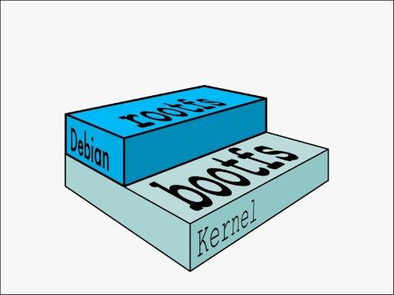

The base images can be enhanced such that they can create the parent images, which in turn can be used for creating the child images.

The base image does not have any parent, that is, the parent images sit on top of the base image.

Note: When we work with an image and if we don’t specify that image through an appropriate identity (say, a new name), then the latest image (recently generated) will always be identified and used by the Docker engine.

In general, the base Docker image represents an operating system, and in the case of Linux, the base image can be one of its distributions, such as Debian.

Adding additional modules to the base image ultimately dawns a container.

When the container is run, the Docker engine not only merges all of the required images together, but it also merges the changes from the read-write layer into the container itself. This makes it a self-contained, extensible, and executable system.

The changes can be merged by using the Docker docker commit sub-command.

The new container will accommodate all the changes that are made to the base image.
The new image will form a new layer on top of the base image.

The following diagram will tell you everything clearly. The base image is the Debian distribution, then there is an addition of two images (the emacs and the Apache server), and this will result in the container:
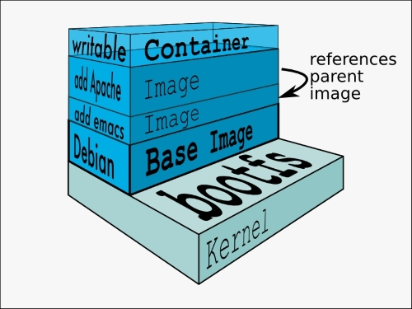
Each commit invariably makes a new image.
This makes the number of images go up steadily, and so managing them becomes a complicated affair. However, the storage space is not a big challenge because the new image that is generated is only comprised of the newly added modules.
In a way, this is similar to the popular object storage in the cloud environments.
Every time you update an object, there will be a new object that gets created with the latest modification and then it is stored with a new ID.
In the case of object storage, the storage size balloons significantly.

A Docker layer
A Docker layer could represent either read-only images or read-write images. However, the top layer of a container stack is always the read-write (writable) layer, which hosts a Docker container.

A Docker container
From the preceding diagram, it is clear that the read-write layer is the container layer. There could be several read-only images beneath the container layer. Typically, a container originates from a read-only image through the act of a commit. When you start a container, you actually refer to an image through its unique ID. Docker pulls the required image and its parent image. It continues to pull all the parent images until it reaches the base image.
A Docker container can be correlated to an instance of a VM. It runs sandboxed processes that share the same kernel as the host. The term container comes from the concept of shipping containers. The idea is that you can ship containers from your development environment to the deployment environment and the applications running in the containers will behave the same way no matter where you run them.
The following image shows the layers of AUFS:
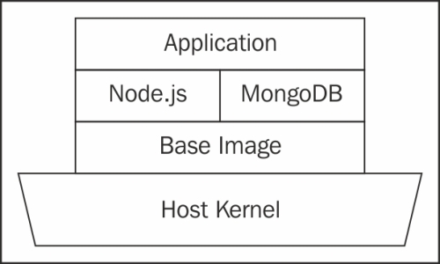
This is similar in context to a shipping container, which stays sealed until delivery but can be loaded, unloaded, stacked, and transported in between.
The visible filesystem of the processes in the container is based on AUFS (although you can configure the container to run with a different filesystem too). AUFS is a layered filesystem. These layers are all read-only and the merger of these layers is what is visible to the processes. However, if a process makes a change in the filesystem, a new layer is created, which represents the difference between the original state and the new state. When you create an image out of this container, the layers are preserved. Thus, it is possible to build new images out of existing images, creating a very convenient hierarchical model of images.

The docker daemon
The docker daemon is the process that manages containers. It is easy to get this confused with the Docker client because the same binary is used to run both the processes. The docker daemon, though, needs the root privileges, whereas the client doesn't.
Unfortunately, since the docker daemon runs with root privileges, it also introduces an attack vector. Read https://docs.Docker.com/articles/security/ for more details.

Docker client
The Docker client is what interacts with the docker daemon to start or manage containers. Docker uses a RESTful API to communicate between the client and the daemon.

Note
REST is an architectural style consisting of a coordinated set of architectural constraints applied to components, connectors, and data elements within a distributed hypermedia system. In plain words, a RESTful service works over standard HTTP methods such as the GET, POST, PUT, and DELETE methods.

Dockerfile
A Dockerfile is a file written in a Domain Specific Language (DSL) that contains instructions on setting up a Docker image. Think of it as a Makefile equivalent of Docker.
Let's take a look at the following example:
FROM ubuntu:latest
MAINTAINER Scott P. Gallagher <email@somewhere.com>
RUN apt-get update && apt-get install -y apache2
ADD 000-default.conf /etc/apache2/sites-available/
RUN chown root:root /etc/apache2/sites-available/000-default.conf
EXPOSE 80
CMD ["/usr/sbin/apache2ctl", "-D", "FOREGROUND"]
The FROM and MAINTAINER fields have information on what image is to be used and who is the maintainer of that image. The RUN instruction can be used to fetch and install packages along with other various commands. The ADD instruction allows you to add files or folders to the Docker image. The EXPOSE instruction allows you to expose ports from the image to the outside world. Lastly, the CMD instruction executes the said command and keeps the container alive.

Docker repository
A Docker repository is a namespace that is used for storing a Docker image. For instance, if your app is named helloworld and your username or namespace for the Registry is thedockerbook then, in the Docker Repository, where this image would be stored in the Docker Registry would be named thedockerbook/helloworld.
The base images are stored in the Docker Repository.
The base images are the fountainheads for realizing the bigger and better images with the help of a careful addition of new modules.
The child images are the ones that have their own parent images.
The base image does not have any parent image.
The images sitting on a base image are named as parent images because the parent images bear the child images.

